1.Print integer entered by user.

import java.util.Scanner;

class Main{

public static void main (String[]args)

{

Scanner sc=new Scanner(System.in);

System.out.println("Enter an integer:");

int n=sc.nextInt();

System.out.println("The integer is:"+n);

}

}

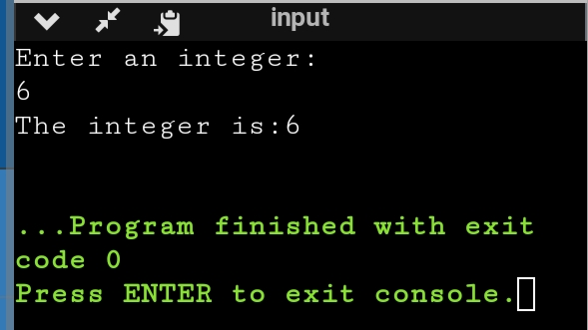

2.Usage of primitive data type

import java.util.Scanner;

public class Main

{

public static void main(String[] args) {

Scanner sc=new Scanner(System.in);

System.out.println("Enter an integer:");

int n=sc.nextInt();

System.out.println("The integer is"+n);

System.out.println("Enter float value :");

float m=sc.nextFloat();

System.out.println("Floating value is:"+m);

System.out.println("Enter the Boolean value:");

boolean t=sc.nextBoolean();

System.out.println("The boolean value is "+t);

}

}

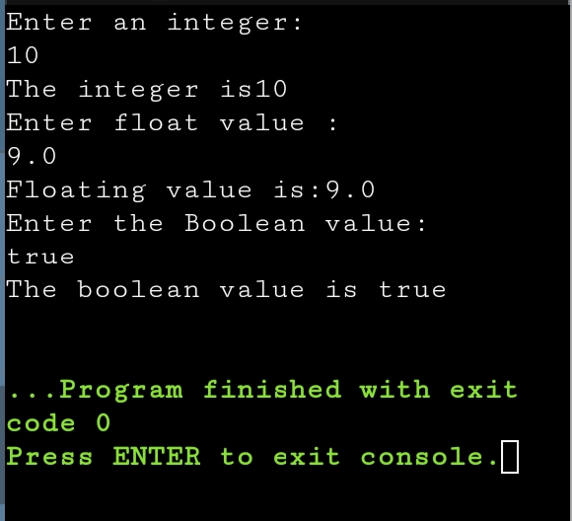

3.Swap two numbers using temporary variable

import java.util.Scanner;

public class Main

{

public static void main(String[] args) {

Scanner sc=new Scanner(System.in);

System.out.println("Enter first number:");

int a=sc.nextInt();

System.out.println("Enter second number:");

int b=sc.nextInt();

int c;

c=a;

a=b;

b=c;

System.out.println("After Swapping :");

System.out.println("First no. is-"+a);

System.out.println("Second no. is-"+b);

}

}

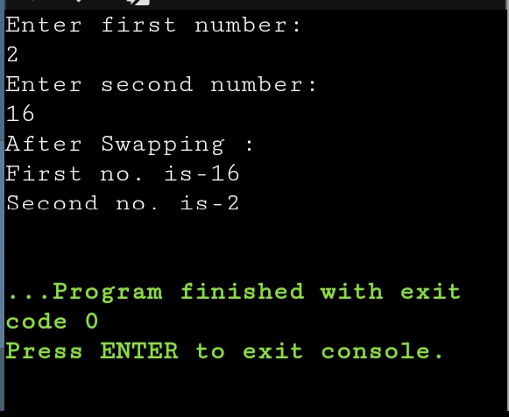

4.Check whether a number is odd or not using if else statement

import java.util.Scanner;

public class Main

{

public static void main(String[] args) {

Scanner sc=new Scanner(System.in);

System.out.println("Enter a number:");

int a=sc.nextInt();

if(a%2==0)

System.out.println("Even Number");

else

System.out.println("Odd Number");

}

}

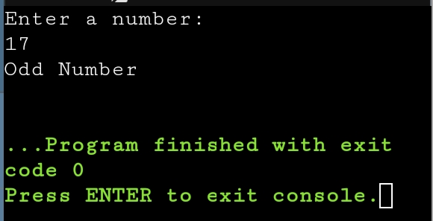

5.Vowel or consonant

import java.util.Scanner;

public class Main

{

public static void main(String[] args) {

Scanner sc=new Scanner(System.in);

System.out.println("Enter a character:");

char ch;

ch=sc.next().charAt(0);

if(ch=='a'||ch=='e'||ch=='i'||ch=='o'||ch=='u'||ch=='A'||ch=='E'||ch=='I'||

ch=='O'||ch=='U')

System.out.println("Vowel");

else

System.out.println("Consonant");

}

}

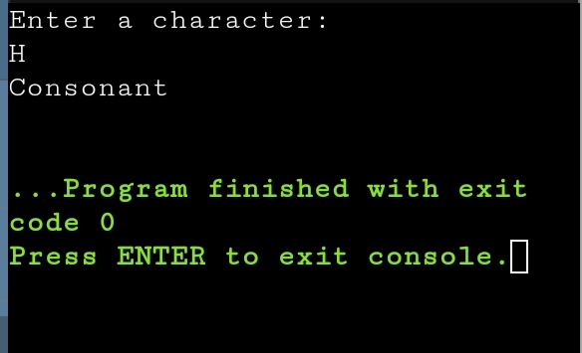

6.Check whether number is positive or negative

import java.util.Scanner;

public class Main

{

public static void main(String[] args) {

Scanner sc=new Scanner(System.in);

System.out.println("Enter a number:");

int n=sc.nextInt();

if(n>=1)

System.out.println("Positive");

else if(n==0)

System.out.println("Neither positive nor negative ");

else

System.out.println("Negative");

}

}

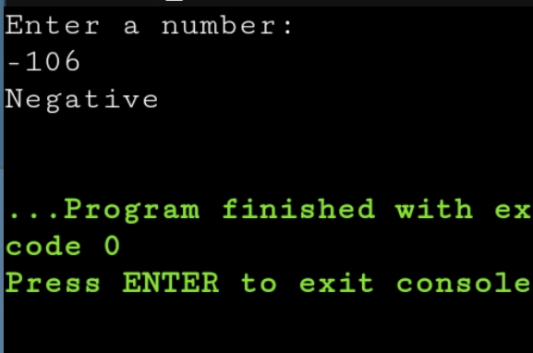

7.Sum of natural number using for loop

import java.util.Scanner;

public class Main

{

public static void main(String[] args) {

Scanner sc=new Scanner(System.in);

System.out.println("Enter no of terms:");

int n=sc.nextInt();

int sum=0;

for(int i=1;i<=n;i++)

{

sum+=i;

}

System.out.println("Sum of n natural number"+sum);

}

}

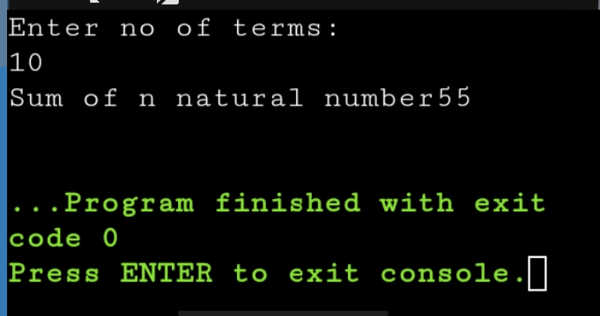

8.Factorial of a number using for loop.

import java.util.Scanner;

public class Main

{

public static void main(String[] args) {

Scanner sc=new Scanner(System.in);

System.out.println("Enter a number:");

int n=sc.nextInt();

int fact=1;

for(int i=1;i<=n;i++)

{

fact*=i;

}

System.out.println("Factorial of number is"+fact);

}

}

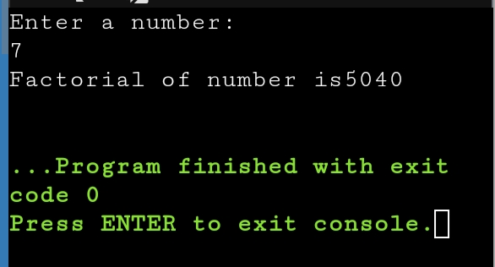

9.Multiplication Table

import java.util.Scanner;

public class Multiplication{

public static void main(String[] args){

Scanner sc=newScanner(System.in);

System.out.println("Enter a number");

int n=sc.nextInt();

for(int i=1;i<=10;i++)

{

System.out.println(n+"x"+i+"="+n*i);

}

}

}

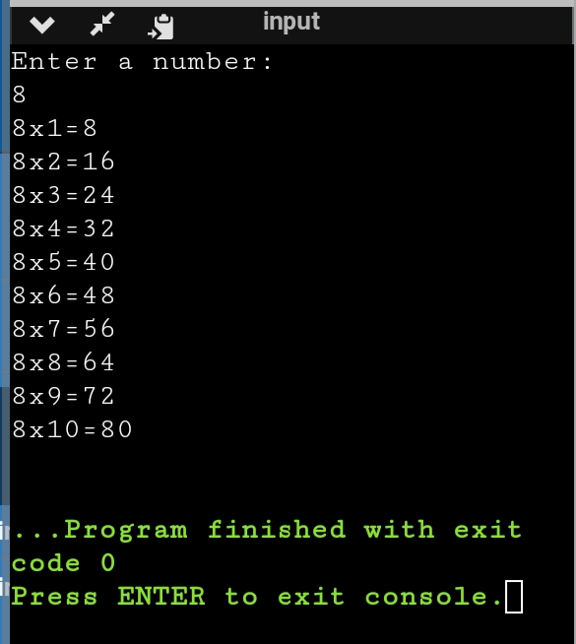

10.Display uppercase alphabet from A to Z using for loop

import java.util.Scanner;

public class Main

{

public static void main(String[] args) {

Scanner sc=new Scanner(System.in);

System.out.println("Upper-case alphabet from A to Z are:");

char ch;

for(ch='A';ch<='Z';ch++)

{

System.out.print(ch+" ");

}

}

}

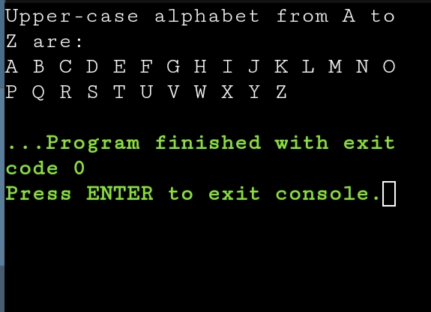

11.Find gcd of two numbers using for loop and if statement

import java.util.Scanner;

public class Main

{

public static void main(String[] args) {

Scanner sc=new Scanner(System.in);

System.out.println("Enter first number:");

int a=sc.nextInt();

System.out.println("Enter second number:");

int b=sc.nextInt();

int GCD=1;

for(int i=1;i<=a&&i<=b;i++)

{

if(a%i==0&&b%i==0)

GCD=i;

}

System.out.println("GCD of two entered number is:"+ GCD);

}

}

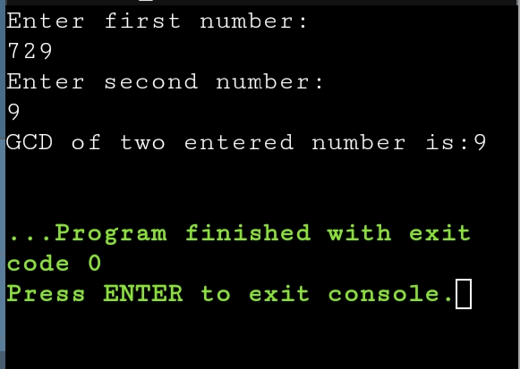

12.Reverse the number

import java.util.Scanner;

public class Main

{

public static void main(String[] args) {

Scanner sc=new Scanner(System.in);

System.out.println("Enter a number:");

int a=sc.nextInt();

int rev=0,q;

while(a!=0)

{

q=a%10;

rev=(rev*10)+q;

a=a/10;

}

System.out.println("Reverse of number is:"+ rev);

}

}

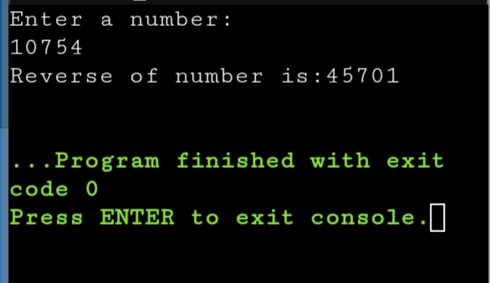

13.Demonstrate creating class and instance (object).

class Student{

int id;

String name;

public static void main(String[] args)

{

Student s1=new Student();

System.out.println(s1.id);

System.out.println(s1.name);

}

}

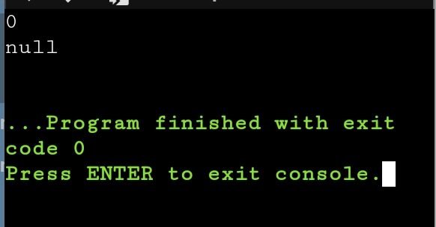

14.Demonstrate using instance/class variable in a java program by creating a simple public class.

public class Studentsrecords

{

/* declaration of instance variables*/

public String name; //public instance

public Studentsrecords(String sname)

{

name = sname;

}

public void printstud()

{

System.out.println("Student Name: " + name );

}

public static void main(String args[])

{

Studentsrecords s = new Studentsrecords("Monica");

s.printstud();

}

}

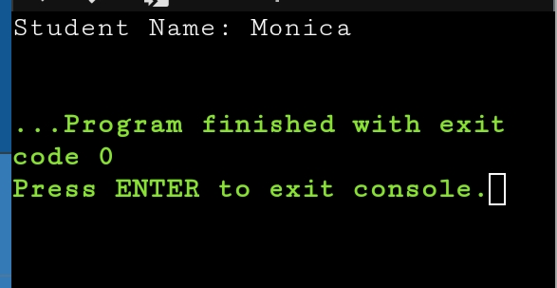

15.Demonstrate the java class using getter setter method for accessing private data member .

class Student{

private String name;

private int rollno;

public void setName(String n) {

name=n;

}

public String getName() {

return name;

}

public void setRollno(int r) {

rollno=r;

}

public int getRollno() {

return rollno;

}

}

public class Main{

public static void main(String[] args){

Student s1=new Student();

s1.setName("ABC");

s1.setRollno(36);

System.out.println(s1.getName());

System.out.println(s1.getRollno());

}

}

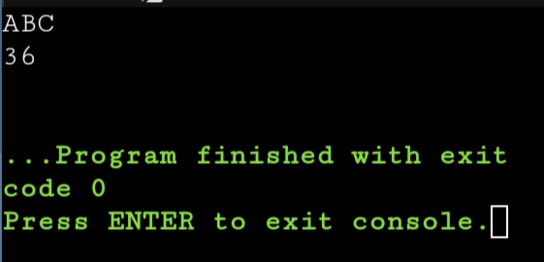

1. Demonstrate the use of static variable

public class StaticVariableDemo {

static int counter = 0;

public StaticVariableDemo() {

counter++;

}

public static void main(String[] args) {

StaticVariableDemo instance1 = new StaticVariableDemo();

StaticVariableDemo instance2 = new StaticVariableDemo();

StaticVariableDemo instance3 = new StaticVariableDemo();

System.out.println("Value of counter: " + counter);

}

}

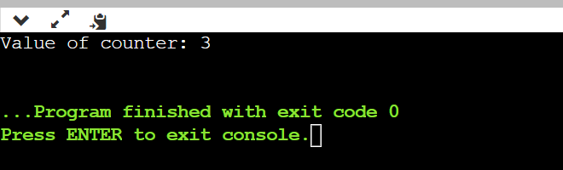

1. Demonstrate the use of static method

public class StaticMethodDemo {

public static int calculateSquare(int num) {

return num * num;

}

public static void main(String[] args) {

int result = calculateSquare(5);

System.out.println("Square of 5 is: " + result);

}

}

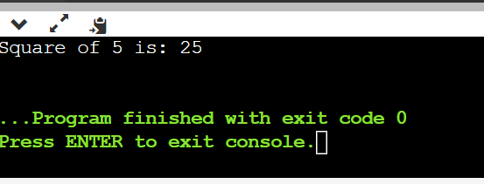

18. Demonstrate the use Scanner class for taking Input /Output from user

import java.util.Scanner;

public class ScannerDemo {

public static void main(String[] args) {

Scanner scanner = new Scanner(System.in);

System.out.print("Enter your name: ");

String name = scanner.nextLine();

System.out.print("Enter your age: ");

int age = scanner.nextInt();

int birthYear = java.util.Calendar.getInstance().get(java.util.Calendar.YEAR) - age;

System.out.println("Hello, " + name + "!");

System.out.println("You are " + age + " years old.");

System.out.println("Your birth year is approximately " + birthYear + ".");

scanner.close();

}

}

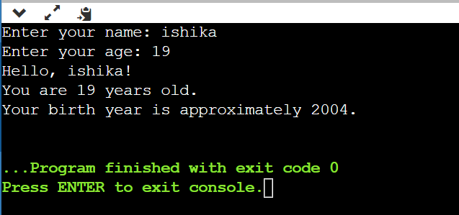

19. Create a program in java to create a class named Light. It contains a variable: On and two methods: switchOn() and switchOff(). Inside the Main class, create two objects: led and halogen of the Light class. Then use the objects to call the methods of the class.

**led.turnOn()** - It sets the On variable to true and prints the output.

**halogen.turnOff()** - It sets the On variable to false and prints the output

class Light {

private boolean On;

public Light() {

On = false;

}

public void switchOn() {

On = true;

System.out.println("Light is now ON.");

}

public void switchOff() {

On = false;

System.out.println("Light is now OFF.");

}

public boolean isOn() {

return On;

}

}

public class Main {

public static void main(String[] args) {

Light led = new Light();

Light halogen = new Light();

led.switchOn();

halogen.switchOff();

System.out.println("LED light is on: " + led.isOn());

System.out.println("Halogen light is on: " + halogen.isOn());

}

}

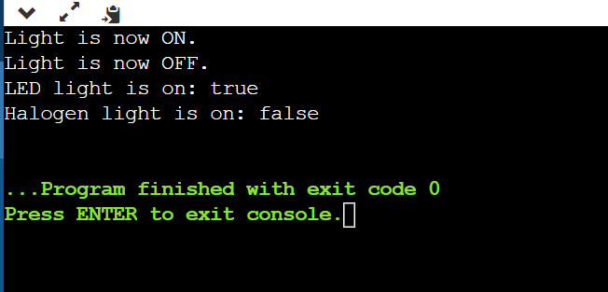

1. Create a program in java to create a class Box with private members as length, breadth, height. Create two methods **getDimension() , setDimension()** to set and get values. Create instances of this class to call the methods.

class Box {

private double length;

private double breadth;

private double height;

public void setDimensions(double length, double breadth, double height) {

this.length = length;

this.breadth = breadth;

this.height = height;

}

public void getDimensions() {

System.out.println("Length: " + length + " units");

System.out.println("Breadth: " + breadth + " units");

System.out.println("Height: " + height + " units");

}

}

public class Main {

public static void main(String[] args) {

Box myBox = new Box();

myBox.setDimensions(10.0, 5.0, 3.0);

System.out.println("Box Dimensions:");

myBox.getDimensions();

}

}

